1. **Problem**

* Need to determine a user’s zodiac sign based on their birthday

1. **Solution Description**
   * Ask the user for their birthday. Test if it’s a valid month. Test if the day is valid for that month. Evaluate how many days the user’s month has and determine based on date ranges what their zodiac sign is. If everything entered is valid print the user’s zodiac sign.
2. **Problems Encountered**
   * At first, I tried to create if statements for each month and each zodiac sign range but figured out I can use or to create an if statement capable of evaluating multiple months with the same number of days.
   * I used only if statements at first, which made me use else at every if statement. I figured out that using else if makes it easier to create a final else statement instead of many separate else statements.
   * Had to figure out how to stop the zodiac sign from printing if invalid days or months are entered by the user. Decided to make a Boolean variable and changed it too false whenever something is invalid. At the end of the program, the zodiac sign will only be printed if that Boolean variable is true.
3. **Flow Chart**

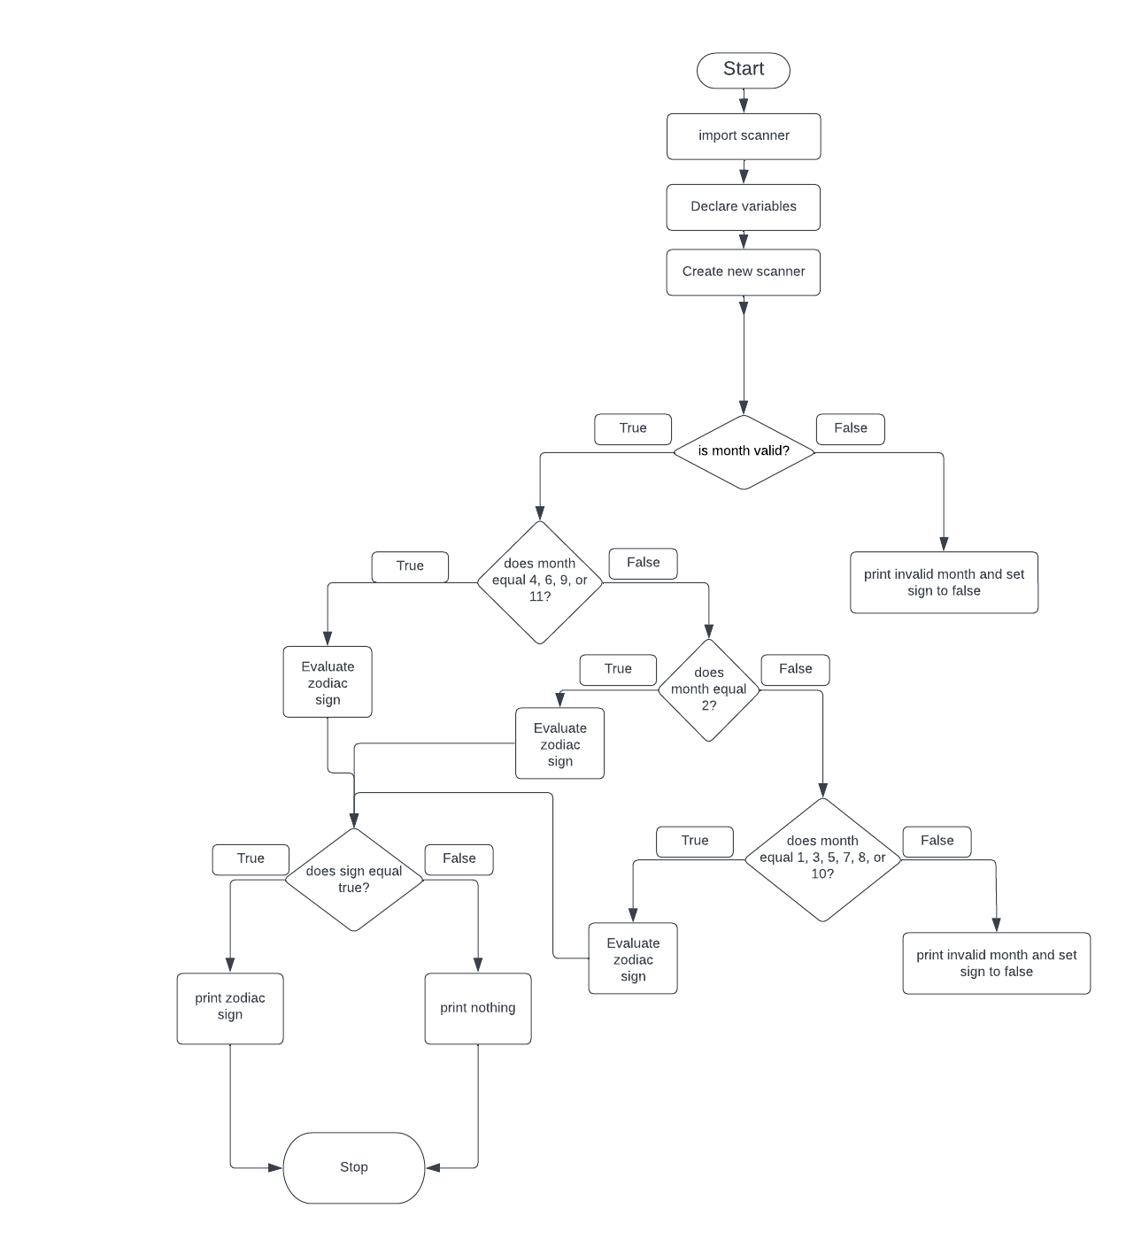

1. **Equivalent Boolean expression** !(a<=b)||!(b>c)

((a>b)||(b<c))

1. **Given the following code snippet, what will the program print to the console**

B

D

G

9

1. **Logic Error**

The logic error in the code snippet is that the programmer used == instead of .equals() for a string variable

1. **Fahrenheit to Celsius**

The code snippet doesn’t print of the correct answer. To fix the error in the code I changed (32-fDegrees)*(5/9); to (fDegrees – 32)*5/9;

1. **Syntax Error**

The syntax error in the code is int something = keyboard.nextDouble();

The programmer tried to use an integer with nextDouble so it is unable to convert from double to int

To fix this make “something” a double

1. **What Prints**

The first letter is a

The second letter is e

The first and last letters are the same